A one-day live
streamed conference
Thursday 13 September

2018
, 9.30am-2.30pm
Including children and young people with additional needs
Belonging supports churches to have a welcoming and accessible ministry with children and young people who have additional needs.
Find out more about our great line up of speakers, and the topics they’ll be covering by visiting www.methodist.org.uk/belongingconference


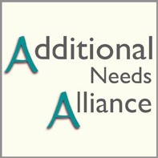
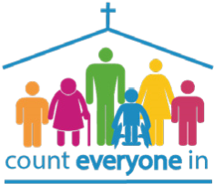
Venue
Northcliffe Church Shipley BD18 3ED
info@northcliffechurch.org.uk
01274 594906
LUNCH PROVIDED
Northcliffe Church
Shipley BD18 3ED
info@northcliffechurch.org.uk

Join Belonging for:
- practical advice
- an opportunity for theological reflection • keynote speakers short ‘lightning’ talks
online interaction.

